Cloud Security DoS Attack Paper

Astro Pryor
Computer Science Department
University of North Texas
Denton, Texas

Bakr Alkhalidi
Computer Science Department
University of North Texas
Denton, Texas

Jacob Bartlett
Computer Science Department
University of North Texas
Denton, Texas

Jay Hernandez
Computer Science Department
University of North Texas
Denton, Texas

ABSTRACT
Cloud computing systems, particularly the ones that incorporate Infrastructure as a Service (IaaS) and containerization technologies, have started to become increasingly targeted by Denial of Service (DoS) attacks and Distributed Denial of Service (DDoS) attacks. This project aims to simulate hybrid cloud scenarios involving both virtual machines and containers to explore the security vulnerabilities and defenses of each. We implemented 4 different and distinct DoS/DDoS attack, a SYN flood (network based attack on a VM), CPU exhaustion (host-based attack on a VM), Slowloris (network based attack against a container) and Fork Bomb (Host based attack against a container).Using Python, we have developed custom monitoring tools that use many different libraries to capture critical system metrics and network behavior. We then stored this data in various ways. Detection mechanisms were also designed using threshold based rules and anomaly detection techniques.When the detection mechanisms go off, automated mitigation strategies are triggered. These include dynamic firewall rule creation using iptables, process termination, rate-limiting and server configuration adjustments. This project demonstrates a comprehensive approach to cloud security integrating attack simulation, real time monitoring, intelligent detection and automated response within a VM and containerized environment. Our methodology highlights practical defenses against common DoS/ DDoS attacks.

INTRODUCTION
A prevalent threat in today’s world is a denial of service (DoS) attack. With the world becoming more virtualized, more services are provided through virtual means. With these services, a certain level of availability and reliability must be maintained in order to serve online clients. This is exactly what DoS attacks serve to disrupt, making services unavailable to legitimate users. Mitigation must be implemented in systems to combat these malicious actions.

This project focuses on four specific attacks, those being SYN flood, Slowloris, CPU exhaustion, and Fork Bombs. SYN flood abuses the TCP handshake, Slowloris holds server connections indefinitely, CPU exhaustion overworks CPU processors, and a Fork Bomb overwhelms a system’s process table.

Naturally, each attack must have their own mitigation. To combat SYN floods, block the offending IP. A network connection is tracked and if the number of half-opened SYN connections passes a threshold in a certain amount of time, the IP is blocked. When dealing with a Slowloris attack, the script captures connections and checks for the number of connections an IP has. If it has enough connections, check for a certain percent of incomplete HTTPS requests and act accordingly. To stop a CPU exhaustion attack, all processes will be analyzed and terminated via process ID if detected as malicious. Using psutil and sklearn’s IsolationForest, processes can be collected, analyzed, and terminated. The Fork Bomb mitigation records the number of processes, where a random spike in the amount of processes, CPU usage, and memory usage can be seen as malicious. Using pkill command, these malicious processes will be terminated.

RELATED WORK

SYN Flood
SYN Flood attacks are a particularly common Denial of Service (DoS) attack. These attacks work by not completing the TCP three way handshake and sending large amounts of SYN packets without completing the connection. This can lead to the exhaustion of server resources which makes legitimate connections impossible. Over the years, there have been several proposed methods to mitigate these attacks, especially since attackers keep changing that way they deploy said attacks.

A study done by Mirkovic and Reiher (2005), provided the comprehensive taxonomy of DDoS attack and defense mechanisms [1]. Their work showed the limitations of static filtering techniques and accentuated the need for more adaptive responses that are capable of distinguishing malicious traffic from legitimate traffic. This study has established a foundation for many modern detection strategies by identifying the key characteristics of SYN Flood behavior.

Going off of the work previously mentioned, in 2018, Dimitriadis and Polychronopoulos studied practical detection methods that specifically targeted SYN Flood attacks [2]. Their research advised that a lightweight mechanism based on monitoring the rate of incoming SYN packets and analyzing the connection patterns that they made would be a good mitigation strategy. This research showed that efficient detection could be achieved without having to rely on complex hardware or intrusive intrusion detection systems (IDS), which would make it a lot more suitable for virtualized and cloud based environments and systems.

In the most recent study that I researched, Zhang et al.(2020) has introduced an advanced detection framework that uses statistical analysis and dynamic thresholding to identify SYN Flood attacks in real time [3]. This approach addressed the challenge of fluctuating network traffic by adapting detection parameters based on the current conditions in a machine, which reduces response times and false positives. This shows that there is an ongoing shift towards intelligent, context aware defense mechanisms that can operate effectively.

While these are pretty good studies that offer insight into SYN detection systems, there are already many solutions out there that focus on large scale environments or that require a lot of computational resources. In contrast to that, this project has a more accessible approach by using a Python based monitoring and detection system that has been tailored for isolated virtual machine use. By simulating real time traffic and attacks and using an automatic mitigation system that uses things like a dynamic firewall rule, the solution for SYN Floods aligns with the previously mentioned studies.

Slowloris
First introduced in 2009 by RSnake [4], slowloris remains one of the simplest yet most effective methods to conduct DOS (denial-of-service) attacks against a web server(s) by exploiting the HTTP protocol. Instead of overwhelming bandwidth or CPU, slowloris keeps many connections open simultaneously by sending particle HTTP requests, consuming server resources.

Research by Kreibich et al. [5] systematically analyzed how slow HTTP attacks operate, demonstrating how such attacks cause resource exhaustion/starvation. Particularly in thread-per-connection web servers like Apache. Their study emphasized the need for detecting incomplete HTTP sessions as an early mitigation process [6]. I will be utilizing this method to detect the slowloris attack for this project.

Real world mitigation efforts at the server level such as Nginx’s client_header_timeout and Apache’s RequestReadTimeout directive, attempt to counter slow attacks by setting aggressive timeout values [7]. These measures do require server side configuration changes, making host based detection when server control is limited. I am doing external, host-level net-based detection.

Recent studies have enhanced our understanding of detecting slow loris and similar http-based attacks. Khandelwal, Lal, and Jindal explored a traffic profiling approach that focused on flow level behavior analysis[18]. Their detection method is advanced and has shown how slowloris detection has been improved. They used handshake completion status, this research also developed a profiling system that flags these anomalies without relying on server logs.

Another study I used is “Detecting slow HTTP attacks based on traffic behavior and header analysis”. This study introduced a practical method to detect HTTP attacks by analyzing live traffic for uncompleted headed [19]. This mainly works on missing or incomplete header detection. My python detection and mitigation script captures HTTP packets using tcpdump, inspects for incomplete header or no http handshake.

CPU exhaustion
Wei Meng et al. [9] highlights the threat newer attacks pose to web apps. It is only logical that over time, DoS attacks will improve and create problems more easily or are more severe. Thus, newer defenses must be made to combat these attacks. Rampart, a defense meant for specifically CPU-exhaustion DoS attacks, is proposed [9]. By using statistical methods, function-level program profiling, and deploying and updating filters, Rampart can dynamically stop these kinds of attacks [9]. Implementing statistical methods and function-level profiling allows for CPU attacks to be accurately singled out.

Ruishan Zhang and Kefei Chen [10] tested the WTLS protocol using various, fabricated DoS attacks. Among these attacks was a CPU exhaustion attack. It was different from the other attacks in the article, as it progresses further in the WTLS handshake in order to send multiple intensive key exchange suites to the server [10]. In response to these attacks, a weak authentication and strong authentication are implemented to validate a client’s IP and the identity of the client [10]. With the IP, these can be blocked in order to deny these computation-heavy actions, effectively dealing with IP spoofing in conjunction with CPU exhaustion.

Mengqi Zhan and et al. [11] introduce Coda, a framework to detect application-layer CPU exhaustion attacks in containers which uses statistical methods in order to detect attacks [11]. After certain system calls, Coda begins the monitoring of CPU time consumed by a connection, and flags connections when they statistically differ from legitimate connections [11].

It can be drawn that using statistics in combination with monitoring tools can be an effective way to detect CPU exhaustion attacks. Using statistical methods allows for you to create a reliable baseline to refer to and simple classification of malicious outliers. Along with this, the powerful combination of running CPU exhaustion attacks with a spoofed IP can be combated with thorough authentication.

Fork Bomb
Fork bombs are a classic type of Denial of Service attack that targets the host system's resources. It mainly targets the process table and memory filling them up at an alarming rate. Unlike network based attacks fork bombs operate locally on the machine consuming resources until the system becomes unresponsive or crashes. This is done by making a process that replicates itself in an exponential manner.

Figure 1: Fork Bomb Visual
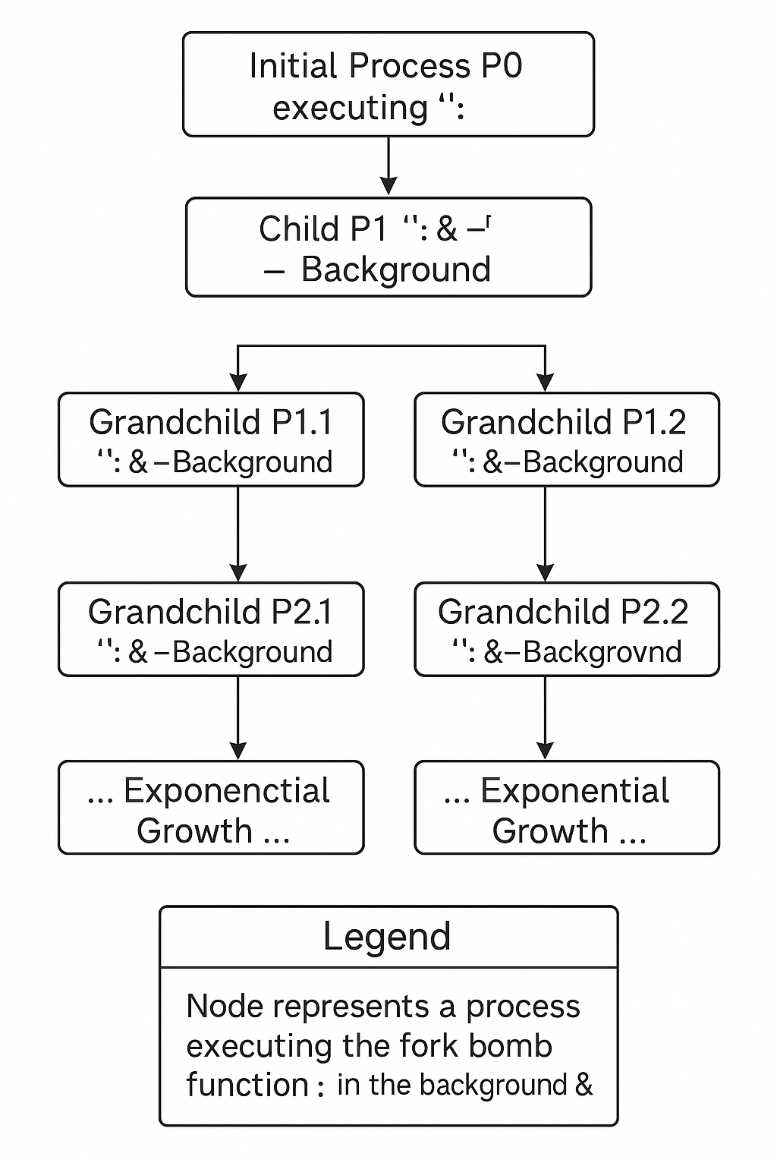

The most infamous fork bomb is the Bash fork bomb :(){ :|:& };: This is known for its effectiveness and ease of use [13] . This easy to make and simple to execute line of code defines a function that calls itself twice in the background causing a rapid rise in process count. There are many other versions in other programming languages but this is the one I chose to use.

Most operating system defenses against fork bombs rely on resource limits. Unix systems call upon the ulimit -u [limit] command to change the resource limit. These are configured by system admins to prevent a single user or process from overwhelming the system. If resources are properly configured resource limits are the best way to prevent a fork bomb.

While doing this provides a prevention at the OS level, runtime detection is also nice by adding a secondary layer of protection when the limits are not as strict as they should be or need an adjustment. Monitoring approaches often involve tracking the total process count or the rate of process creation, flagging sudden, unsustainable increases as potential fork bomb activity. My project utilizes such a runtime monitoring and detection approach as a host-based defense within the container itself.

SOLUTIONS

SYN Flood
The goal of this project was to detect and mitigate SYN Flood attacks by using an attack simulation script in an efficient and practical way. Building off of the research previously mentioned, my approach uses a lightweight monitoring, real time detection, and automated response mechanism.

My overall approach to this solution was to provide continuous protection against SYN flood attacks by integrating custom built monitoring and detection tools that have automated mitigation techniques installed. The system is designed to only operate within a virtual machine environment which reflects common infrastructure as a service (IaaS) scenarios. I chose Python for both of the scripts because they have flexibility and a lot of networking and system monitoring libraries.

For the implementation of the attack, I used a Python script that uses the socket library. This tool helps to generate a high volume of SYN packets that are then directed at a targeted VM without completing the TCP handshake.

My solution has 2 different parts to it, an attack portion and a mitigation portion, one to attack and one to defend basically. The defense portion integrates a TCP server with embedded monitoring and detection logic and is supported by an automated firewall configuration for mitigation. Figure 2 shows the high level architecture of the system. It shows the interaction between the attacker, the monitoring script, detection logic and mitigation response (Figure 2)

The core workflow consists of four different stages:
Attack Generation
Traffic Monitoring
Anomaly Detection
Automated Mitigation and Logging

Each of these components are designed to operate autonomously and require minimal intervention once they are deployed.
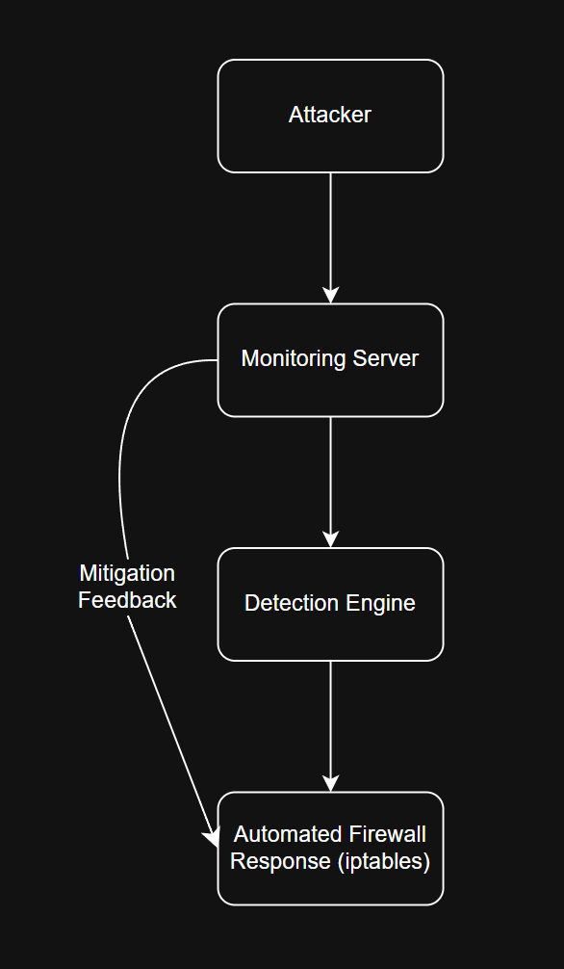
Figure 2: System Architecture for SYN Flood Detection and Mitigation
(Diagram showing: Attacker -> Monitoring Server -> Detection Engine -> Automated Firewall Response)

Attack portion
My attack script uses the socket and threading libraries. The point of the script is to generate a high number of incomplete TCP connection attempts by initiating connections without completing the handshake (Figure 3). This method targets the vulnerability that is inherent in the TCP protocol, which is that server resources are almost always allocated when receiving a SYN packet.

Figure 3: SYN Flood Attack Flow
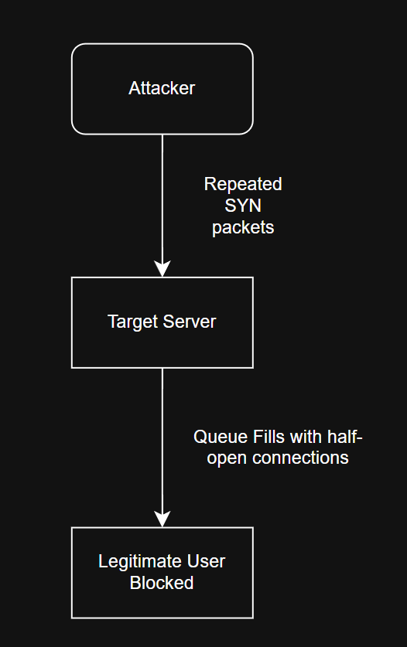
(Diagram shows repeated SYn packets send without completing the handshake, which leads to half open connections on the target server)

My attack script is also configurable and allows the user to define the
Target IP Address
- Target Port
- Duration of Attack
- Number of Threads
By using multithreading, that script maximizes the rate that SYN packets are sent, which effectively overwhelms the server's backlog queue during testing.

Monitoring
The monitoring portion of my mitigation script uses a custom built TCP server using the socketserver module. Unlike other monitoring tools, my server inspects the connection attempts in real time as part of the core functionality. From there, the script tracks the number of half open connections per IP address and also the rate of incoming connection attempts within the specified detection window. All of the events, including the blocked ones, are then logged into a SQLite database for traceability and analysis for later (Figure 4). This approach specifically avoids unnecessary overhead so that the server can remain responsive even under high traffic conditions.
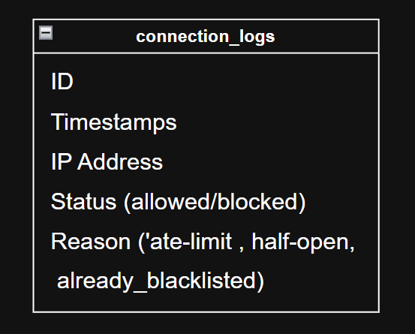

Figure 4: Database Schema for Connection Logging
(Shows the structure of connection_logs table: IS, Timestamp, IP, Status, Reason)

Detection Mechanism
My detection mechanism relies on dynamic thresholding where two main conditions trigger an alert. The first one is an IP address exceeding 50 half open connections and the second one is if more than 20 connections attempt from the same IP within a 5 second window. These are the default configurations however, and can be changed as the user wishes.

I specifically added those specific thresholds so that the script can avoid any false positives and also balance any sensitivity the script might have. The system continuously evaluates connection patterns using the deque data structure for more efficient time window tracking. Once the threshold is breached, the IP address is immediately flagged and the mitigation procedures are done.
As shown in Figure 5, the detection engine applies threshold based rules to identify any suspicious activity.

Figure 6 shows the detection process, where the incoming connections are evaluated against historical data to identify any suspicious behavior.
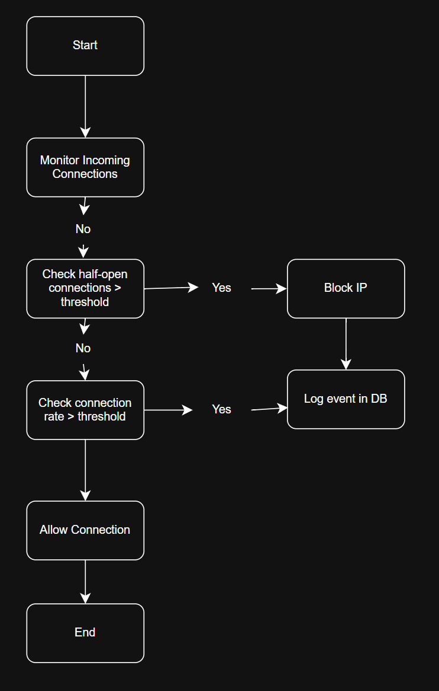

Figure 5: Flowchart of SYN Flood Detection Logic
(Diagram showing steps: Monitor -> Evaluate Thresholds -> Flag suspicious IP -> Trigger Mitigation)

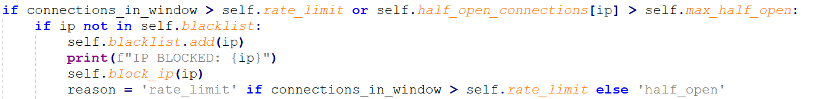
Figure 6: Threshold Based Detection Logic for SYN Flood Attacks
(Shows the core detection mechanism)

Mitigation and Prevention
When there is malicious activity detected, the system will enforce the automatic countermeasure against the offending IP. These include
Adding the offending IP to the serves blacklist
A corresponding iptables rule inserted dynamically to drop all future packets from that IP
Log the action in the database with details of the triggering condition
Additionally, SYN cookies are enabled at the server level to provide more resilience against the sudden spike of half open connection in the attack's early stages.

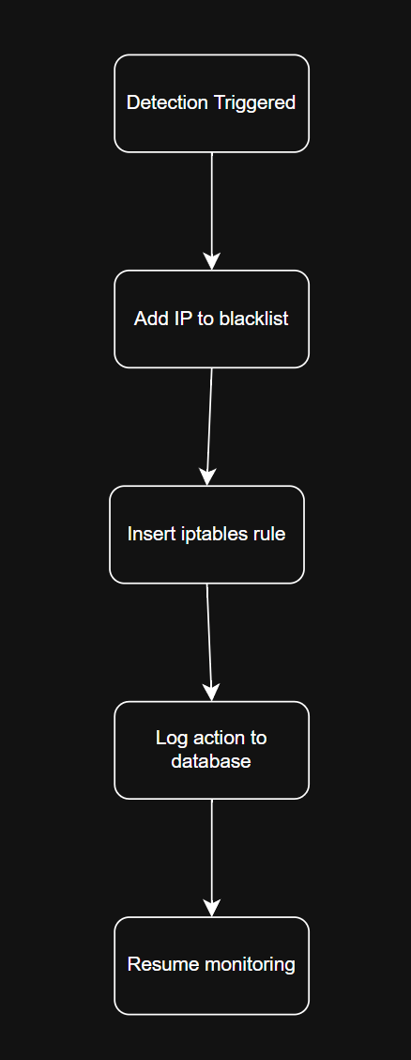
The automated mitigation script makes sure that the server can recover from the attack conditions without needing a manual firewall configuration or for the service to restart. Figure 7 shows the end to end flow from attack detection to mitigation. Figure 7 shows how the system automates defensive response through firewall rule insertion.

Figure 7: Automated Mitigation Workflow
(Diagram showing detection triggering iptables rule insertion and updating the database log)

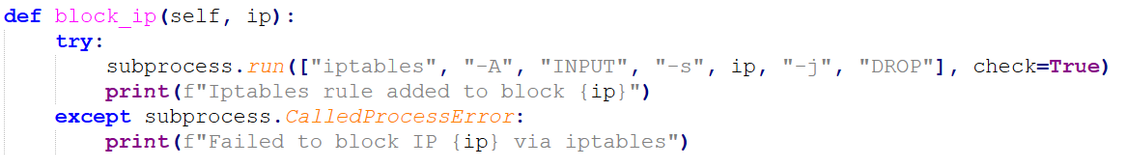
Figure 8: Automated Firewall Rule Insertion Using iptables
(Shows how the system enforces mitigation by dynamically updating the firewall)

Slowloris
My Solution for slowloris focuses on implementing a lightweight host-based defense system that is capable of detecting and mitigating slowloris attacks without web server settings. Our solution consists of 2 major components, a Python-based detection and mitigation code (slowloris_detect-mitigate.py), and a C++ based slowloris attack simulator (slowloris_attack.cpp).

The detection and mitigation system operates inside a container environment using Docker to allow for easy deployment across any host [5]. The detection monitors TCP connections to port 80 (HTTP) passively and analyzes HTTP traffic payloads in real time. I implemented simple but effective standards, which are id an IP establishes more than 10 concurrent TCP connections it is flagged for deeper analysis. Using tcpdump we capture packets that allow us to inspect live HTTP traffic, searching for incomplete HTTP headers or missing critical fields such as Host:. A key decision for an IP to be marked as malicious is incomplete request ratios, if its over 50% then an Ip is marked as malicious.

When a malicious IP is detected, it is blocked dynamically using iptables, preventing further communication to port 80. I also implemented an unblocking feature for testing, which avoids banning legitimate users during testing and issues. By preforming all operations at the network layer and using standard linux utilities (netstat, tcpdump, iptables) my approach remains portable and independent of any specific server software.

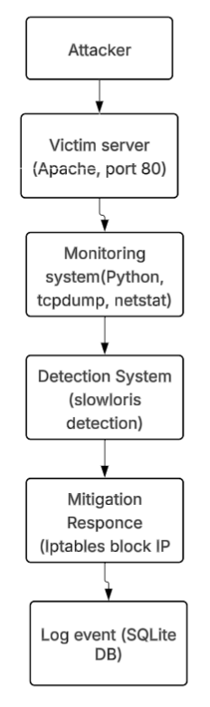
Figure 9 : System Architecture Overview. This diagram visualizes the architecture of the attack, monitoring, detection, mitigation, as well as the log process.

Attack Implementation
The slowloris attack simulation (slowloris_attack.cpp) was implemented in C++ using socket programming and multithreading. Upon execution, the tool requires four arguments in this order: target IP, port number, number of sockets, and number of threads. For each thread, the tool creates multiple TCP sockets and connects them to the target server. Each socket sends an incomplete HTTP request, missing essential fields like complete Host: or counter-length headers.

To make the attack more complex, I made the program periodically send small header fragments over each socket, which prevents server-side timeouts that expect data progression. The multi-thread architecture ensures that a large number of sockets can be maintained concurrently, maximizing the stress applied to the target server.

This effectively simulates a real-world Slowloris attack scenario, in which the A[pache server is exhausted and prevents legitimate users from accessing the service. Next we will talk about the monitoring attack and how we can watch the slowloris.

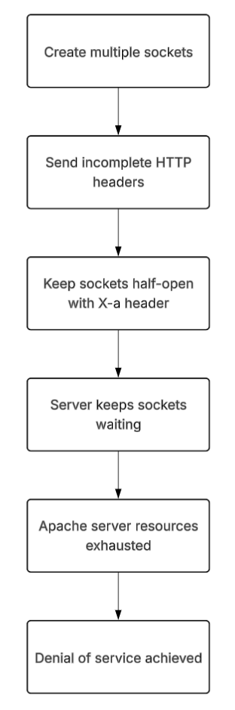
Figure 10: Attack execution flow. This outlines how the attack is carried out in steps. Incomplete headers prevent Apache from closing the socket, keeping the server’s thread pool occupied.

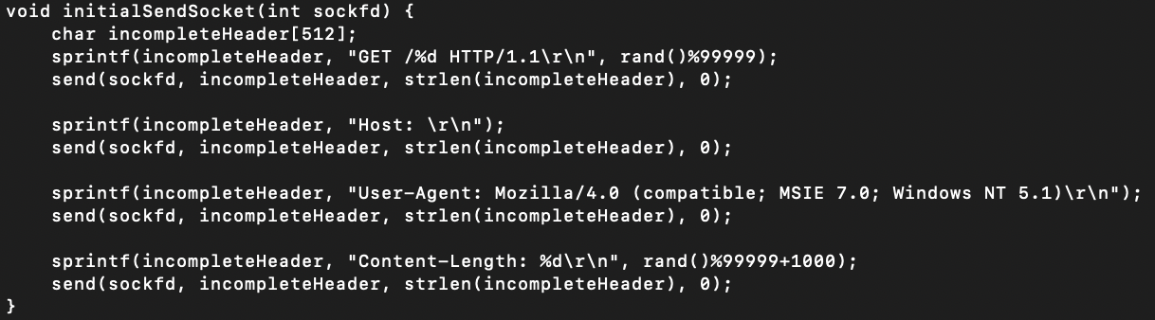
Figure 10: This function is responsible for launching the slowloris behavior. This is the part of the attack that sends incomplete HTTP request headers to the server. Each server header that is sent is missing a required value or the final \r\n\r\n termination. This causes the server to wait for the full request, which takes up resources.

The use of rand() ensures that each request is slightly unique which is super important because it helps avoid basic IDK/IPS filtering. The headers are sent in stages ( ex: host: with no hostname) to maintain half-open connections, which exhausts the server's thread pool.

Monitoring approach
The monitoring method combines an active TCP connection counter with live HTTP traffic load analysis. The monitoring system executes netstat every 5 seconds to check all established TCP sessions, which also filter for those targeting port 80. This allows early identification of IPs with high connection counts.

Once an IP crosses the predefined connection threshold, the system starts packet capturing. It captures up to 400 TCP packets from the marked suspicious IP. Capture loads are then parsed to identify HTTP request lines and detect header for the presence of completion. This dual monitoring I connection counts and payload content) balances speed with accuracy, which provide a great detection mechanism without deep inspection engines like Suricata [3]

Using simple Linux tools like netstat and tcpdump the monitoring remains lightweight, this is important to me because I wanted to ensure minimal overhead on the vm and host.

Detection strategy
The detection in my system follows a 2 step process. First Ip address are evaluated based on their connection density. For instance, an IP with more than 10 concurrent connections is flagged as suspicious. Secondly, the payloads from the IP are analyzed to measure the proportion of incomplete HTTP requests.

If more than 50% of captured HTTP requests from an IP are missing mandatory fields like host, user agent, or a complete request structure ending with \r\n\r\n, then the IP is classified as a Slowloris attack. This method was inspired by behaviors observed in experimental detection systems, such as described by Mirkovic and Reiher [6]. My detection prioritizes accuracy while maintaining low overhead, ensuring rapid response without compromising legit traffic.

My approach ensures early detection by combining both quantitative( connection counts) as well as qualitative (incomplete HTTP) checks.

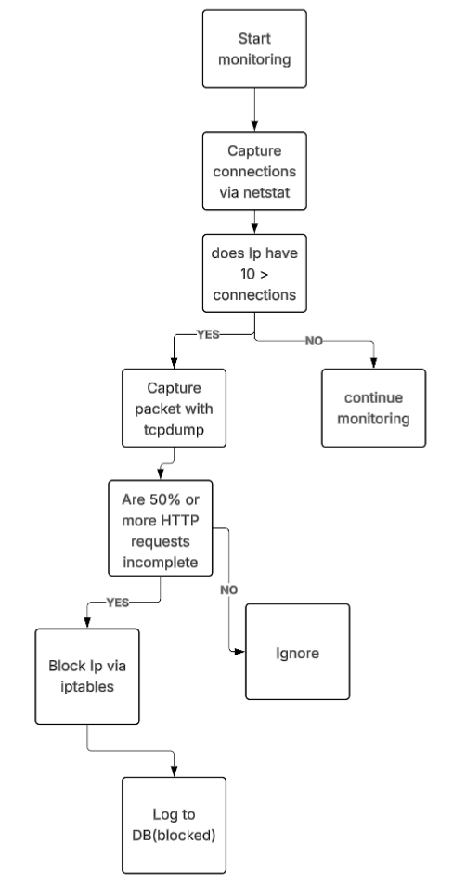
Figure 11 : Attack detection and mitigation logic. This figure shows how Ips are first evaluated by connection count, then by the quality of the HTTP headers. And it also shows the metrics for blocking the IP.

Mitigation and prevention
Once an Ip is detected as malicious, mitigation is activated. The system then issue an iptables rule to drop all incoming TCP packets from the offending ip of port 80.

This strategy ensures resilience against false positives and transient network anomalies while still providing effective immediate defense. The use of iptables ensures compatibility across a wide range of environments without requiring specialized firewall or kernel.

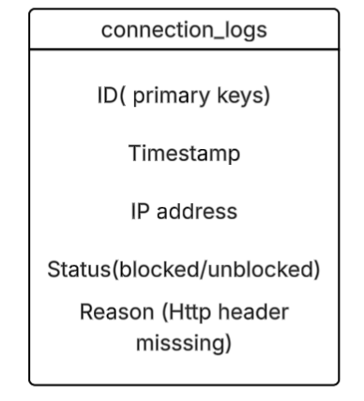
Figure 12: This figure shows the connection logs schema which is for the database. These are the attributes that will be outputted when we output the information in the database when using Sqlite3.

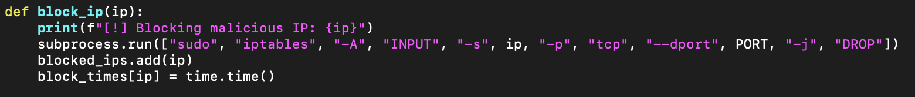
Figure 13: The following function enforces mitigation by dynamically blocking traffic of detected malicious IPS( detected by the analyze_http_traffic function). Once the IP is flagged its blocked to the system firewall using iptables, this drops all incoming traffic from that IP. The timestamp is also recorded for use in the database.

CPU exhaustion
This attack targets one of the most valuable resources of a computer system, the CPU. By keeping CPU processors busy, it will slow down all other processes running on the system. Two python libraries, scikit-learn and psutil, were used to create a bulk of the mitigation script. The sqlite3 library was implemented as well to initialize a database and record all processes and their information. Using process management functions from psutil allows for the creation of a monitoring function and a termination function. The detection function was mainly implemented by scikit-learn’s IsolationForest, which builds trees using data from the monitoring function in order to predict what processes are anomalous. All data was recorded to the “cpu_data.db”, in which a table named “process-usage” stores the date and time of the logging, the process ID, the process name, and the CPU usage as a percentage.
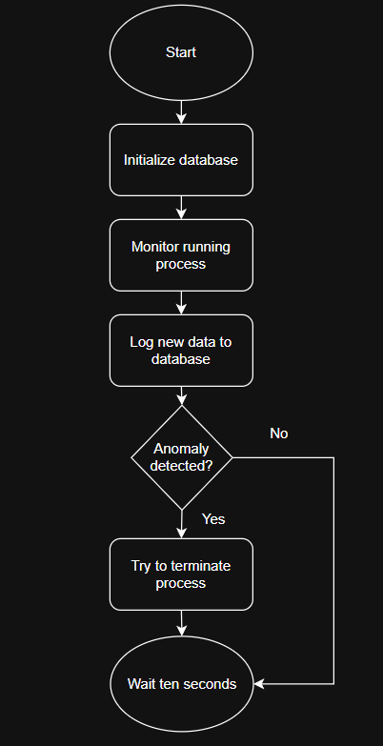
Figure 14: Simple Flowchart of CPU Exhaustion Mitigation
(Shows basic logic of the mitigation script)
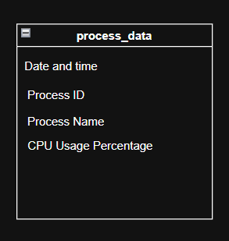
Figure 15: Table Schema
(Columns of the table)

The attack script wastes the CPU’s resources by keeping it busy, effectively slowing down a system. Using the multiprocessing library, this script works by creating multiple processes for each CPU core, running an infinite loop for each of the CPU cores, and finally waiting for each process to finish. Seeing as to how the processes are running infinite loops, the script waits indefinitely for each process to finish.

I am monitoring all active, alive, and unique processes that are not the script itself in my virtual machine. This means that I only monitor processes that are non-idle, processes that are not terminated, and processes that have not been seen before already. I carry out this monitoring via the “monitor_cpu” function. In this function, I create an empty list, process_info, to store process information, as well as a set, seen_pids, to determine what processes have already been seen. Then, using a for loop, all the requested data about a process (process id, name, and CPU usage percentage) is collected. It is then tested to see if the process is the script itself, if the process is alive, and if the process has not already been collected. If it passes all the conditions, the process ID is sent to seen_pids and the process is appended to the process_info list. The data collected is then returned as a list of dictionaries.
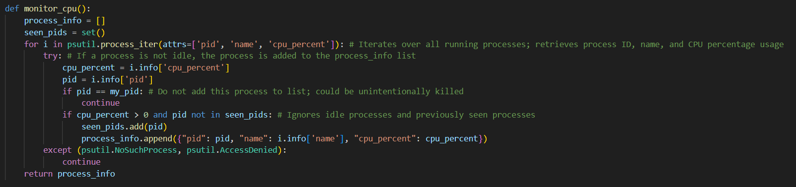
Figure 16: Monitor function
(For clarity)

Attacks are detected using the “detect_anomaly(data)” function. Once enough data is collected, the list of dictionaries is converted into a list of lists of CPU usage as a percentage, the required format for IsolationForest [12]. An IsolationForest model is created where it is expected for ten percent of entries to be anomalies where results should be reproducible. This model fits with the list of lists made earlier in the function. With this data now in the model, a prediction list is made from the data, where 1 stands for normal CPU usage percent and -1 stands for abnormal CPU usage percent. This will tell you which index the anomalous process is at in the original list of dictionaries. In a final for loop, these processes are appended to an anomaly list of dictionaries. If there wasn’t enough data, an empty list is returned.
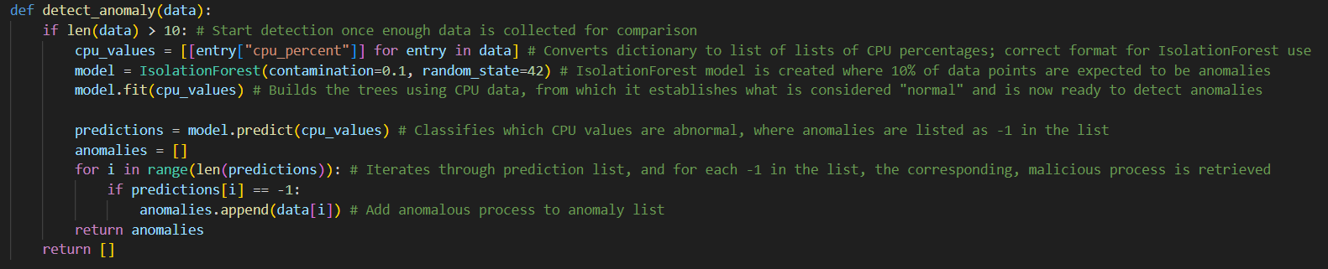
Figure 17: Detection function
(For clarity)

Processes are killed via the “terminate_process(pid)” function, which uses the process ID to accurately end a process. First, it tries to terminate a process by using psutil to retrieve a process for a specific process ID. That process is then terminated and a message is printed and returns True if there are no errors. If an error occurs, it will print an error message and return False.
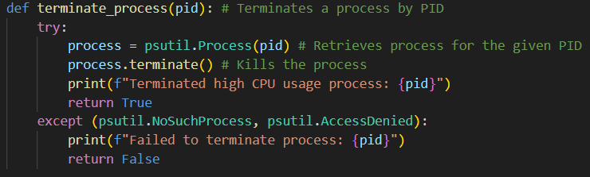
Figure 18: Termination function
(For clarity)

Fork Bomb:
The fork bomb attack represents a host based Denial of Service vector that aims to exhaust the system resources resulting in either the system becoming unresponsive or crashing. This is done by targeting the process table and replicating processes. My solution focused on detecting and mitigating this attack within a container using lightweight monitoring and a direct mitigation strategy.

My approach to this was compiled of 3 key components within the Docker container: The fork bomb itself (fork_bomb.sh) a monitoring script (monitoring.py) and also a detection/mitigation script (detector.py). This simulates an attack and puts my methods of mitigation to the test in a controlled environment. I also used Python, psutil library for monitoring and SQLite for logging as well as some standard Linux commands.

Attack implementation:

I used the classic bash fork bomb for this scenario.
:(){ :|:& };:
This function works by calling itself twice with each call running in the background. This leads to an exponential growth of processes leading to the machine hitting its resource limit. If this limit is not set it can lead to crashes and make the machine unresponsive. If proper resource limits are set the machine might slow down depending on what % of the resources are being allocated by this process.

EXPERIMENTS

SYN Flood
To evaluate how well my scripts work, I conducted a series of controlled experiments in my virtualized environment. I was looking for how well the response time was, the overall ability of the system to maintain service while under attack and the accuracy of detection.

The environment that I used is Ubuntu 22.04 LTS with 16 GB ram, 4 processors and 30 GB of available storage. Both of the VMs that I used had the same environments. I used Python 3 to write the scripts and SQLite for the database.

The default parameters for the mitigation script are max half open connections allowed - 50, the detection window - 5 and the rate limit at 20. Each of the experiments I performed changed the parameters to simulate different network activity.

Test Case Name | Thresholds (half open connection / time window / rate limit) | Results
High intensity | 20/3/10 | Blocked the attempt after 2 seconds
False Positive | 5/2/3 | Blocked the attempt immediately
Lenient | 150/15/75 | Blocked the attempt after 9 seconds
Stress Test | 30/1/15 | Immediate detection

Figure 19: Table of different tests performed

From Figure 19, you can see that I performed 4 different tests, a high intensity, false positive, lenient and stress test. For each of these experiments, the IP ended up being blocked almost immediately or after a couple of seconds.

High Intensity
The system almost immediately blocked this attempt and responded in a timely manner to the SYN Flood activity. This experiment showed that even under high activity the mitigation script will still work.
False Positive
I changed the thresholds to be extremely low to simulate normal activity and the IP was immediately blocked. This shows how important it is to figure out the balance between security and usability. In a real implementation, the thresholds would never be this low, but I did this to showcase that the mitigation script will work under any conditions.
Lenient
This experiment was designed to see how long it would take to block an IP if the thresholds were set really high. This is a good example of how overly permissive configurations can eventually lead to things being overlooked. In a real implementation, the thresholds would never be high enough that it takes a long amount of time to block the IP address.
Stress test
This experiment tested my scripts when the attack conditions are particularly aggressive. The mitigation script detected the SYN Flood almost instantaneously which shows just how capable the script is.
Through these tests, the balanced configuration, which is the default parameters, were determined. The script also tracks the CPu and memory too. Throughout each of the tests the system maintained stable resource consumptions with the CPU usage peaking during the attack periods. It went back to normal usage after the IP was blocked though.

The SQLite database was also effective in each of these tests. It detailed the log of all connections that were attempted along with the detections and mitigation actions. This provides a pretty clear trail if the system even gets audited and it verifies that the automated responses were working as intended.

Overall, the system pretty consistently identified the SYN Flood and mitigated it by blocking the IP address that was sending it.

Slowloris

Testing for the attack and defense of SlowLoris were conducted on a virtual machine as well as a container to detect and mitigate attacks. We tested the attack with these parameters: 192.168.64.3 for the IP of the vm we are attacking, port 80 as well as 200 for sockets and 5 for the number of threads. The detection system, running inside Docker, successfully detected and mitigated the attack within about 10-15 seconds after the initial attack was running.

The detection and mitigation maintained 100% detection accuracy across multiple runs of the system, No false positives were observed during normal traffic generation ( browsing with chrome). Resource usage remained normal.

These results proved that the system is both efficient and effective at detecting and mitigating the Slowloris attack.

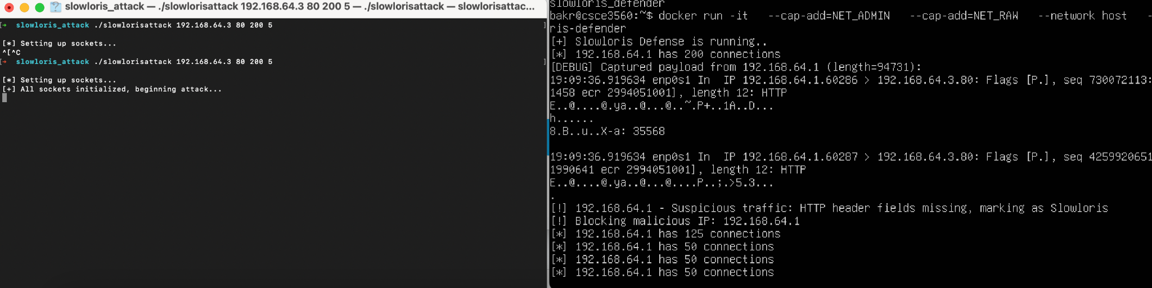
Figure 20: This is a standard attack with 200 sockets and 5 threads in the attack (left). As we can tell by the detect and mitigate script (right side). The IP of the host was blocked by the vm.

I also did an attack where I increased the number of sockets which puts a much higher strain on the detection and mitigation processes. I used the same port but I changed sockets to 2000 to send an aggressive attack and I changed the threads to 20.
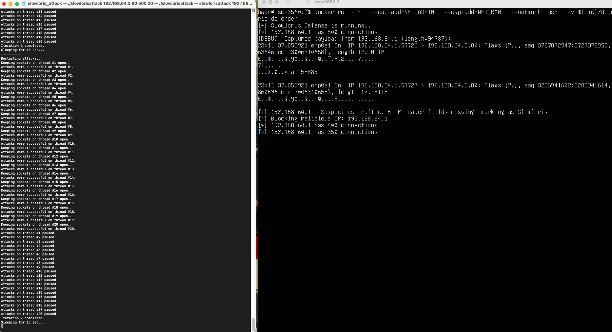
Figure 21: This shows an attack running 500 sockets and 20 threads for a more concurrent operation, thus giving the attack a higher Dos likelihood, but the code still mitigated the attack and blocked the IP.

These tests prove that the detection and mitigation script won't just fail due to an increase of sockets and threads, which is what we want for a slowloris attack and a slowloris detect and mitigation script.

I also tested my script before and after running my attack and I did that by curling Apache. Before I sent the attack and detect/mitigation scripts Apache worked and responded perfectly. Then when I ran the detection/mitigation and the attack and the IP got blocked I tried to curl Apache again and It didn't work.
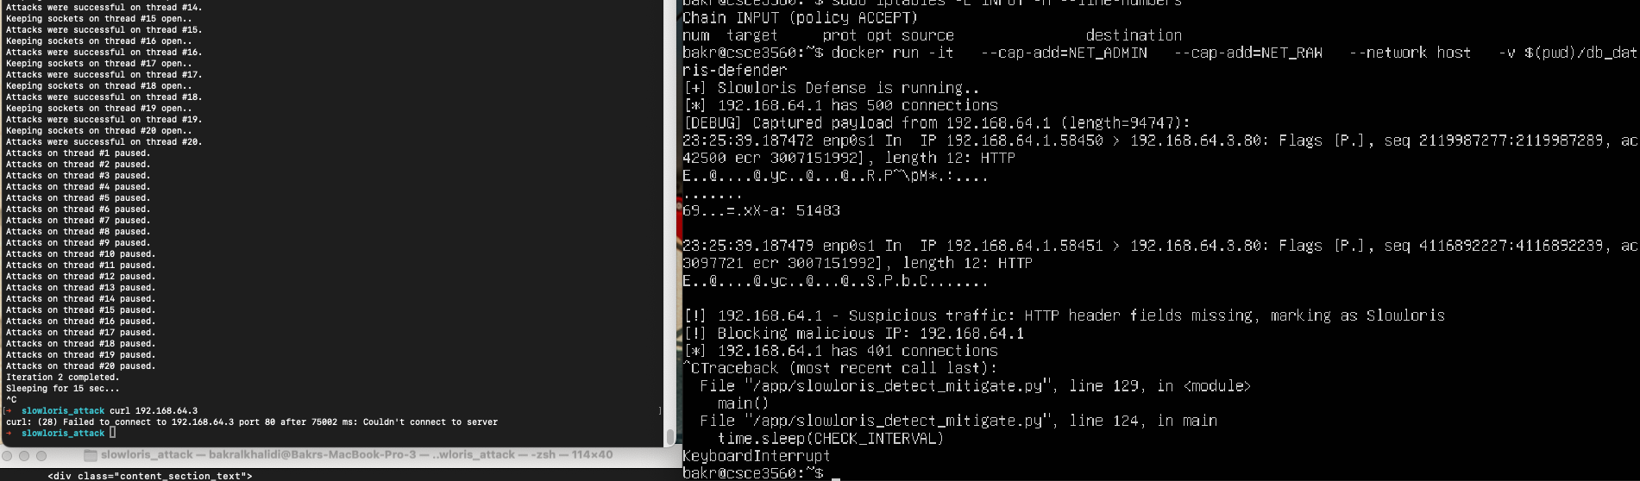
Figure 22: showing that apache is not responding and that it failed to connect to the server.

My response between detecting and mitigating is about 15 seconds after I send the slowloris attack. It consists of 15 seconds and doesn't take any more time than that. The only way it would is whenever the IP is already blocked. If the IP is blocked then the process of detection would run but it wouldn't block anything because it already had it blocked with iptables as well as its in the database.

CPU exhaustion
In order to test the boundaries of your code, you must experiment with it, which is exactly what I did. I wanted to see how far I could push my code in order to see what it is capable of and what it is not capable of. I ran these experiments on a single Ubuntu 24.04.2 LTS with the XCFE desktop environment with only 1 CPU, 1.9 Gb of RAM, and 20 GB of disk space.

My first experiment deals with multiple attacks occurring at the same time. This is a very simple experiment, yet an important one. It can not simply deal with just one, and my mitigation must be quick as to not affect legitimate users.
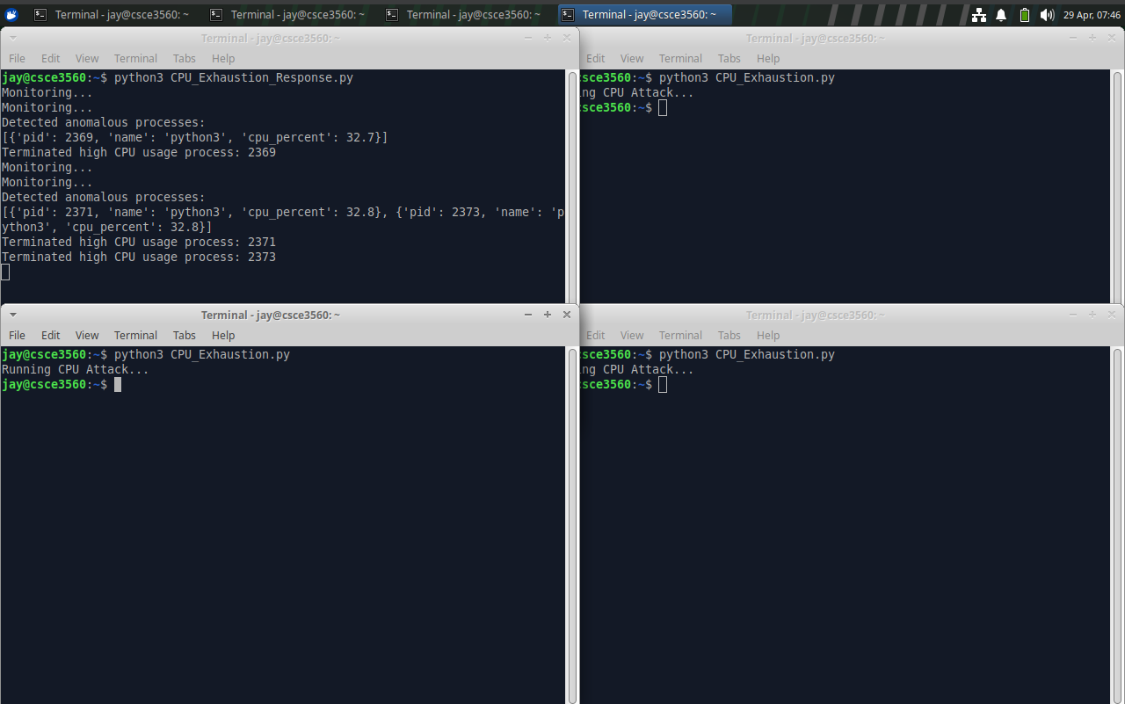
Figure 23: Results of Experiment 1
(Shows that the script effectively dealt with the three simultaneous attacks in about thirty seconds)

As we can see from Figure 23, the script effectively dealt with the attacks. This outcome is favorable, since despite attacks from multiple processes, it has the capability to deal with these, along with in a fair amount of time.

My second experiment deals with giving my script more power. Specifically, running the command with “sudo” should give it access to root user privileges, which can be a double-edged sword. My goal with this one is to safely mitigate the attack, without harming anything else in the virtual machine or script.
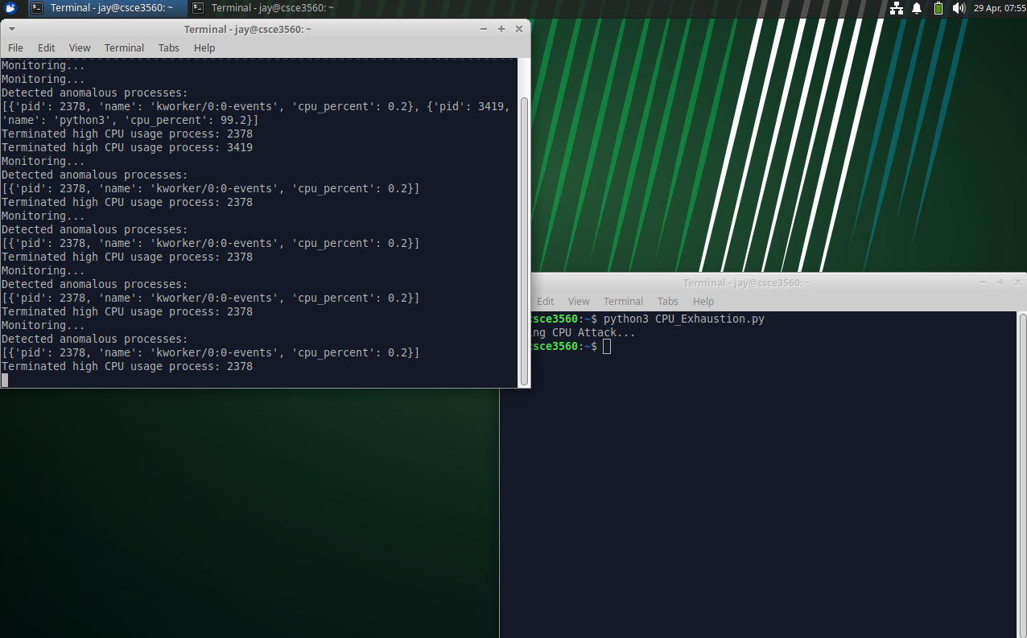
Figure 24: Results of Experiment 2
(Did mitigate the attack but displays the same processes constantly being terminated; should not be possible)

While the attack was mitigated in a fair amount of time, too much power seemingly broke the code. My code is set up in a way that it will not constantly try to terminate dead processes. Although it did not happen, it must be assumed that more severe consequences can happen due to the elevation of privilege.

My third experiment revolves around actually changing the code, in which I change the monitoring times. Decreasing the monitoring times may influence the prediction of anomalies by creating a smaller data set, which could potentially cause the script to try to terminate a process it would not normally try. Increasing the monitoring time, on the other hand, may take too long for predictions to take place.
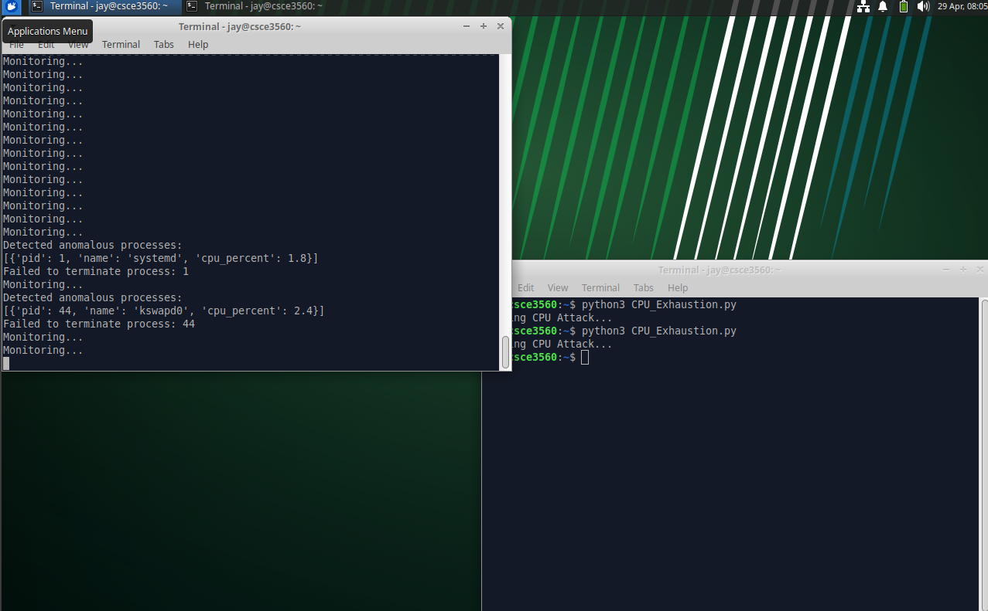
Figure 25: Results of Experiment 3 Part 1
(Process ID 1 was attempted to be terminated)

The mitigation worked within 30 seconds, but this is an interesting outcome. I have never had the process ID of 1 show up in my failed terminations. If the script had the power to terminate the ‘systemd’ process, it may very well shut down the whole virtual machine.
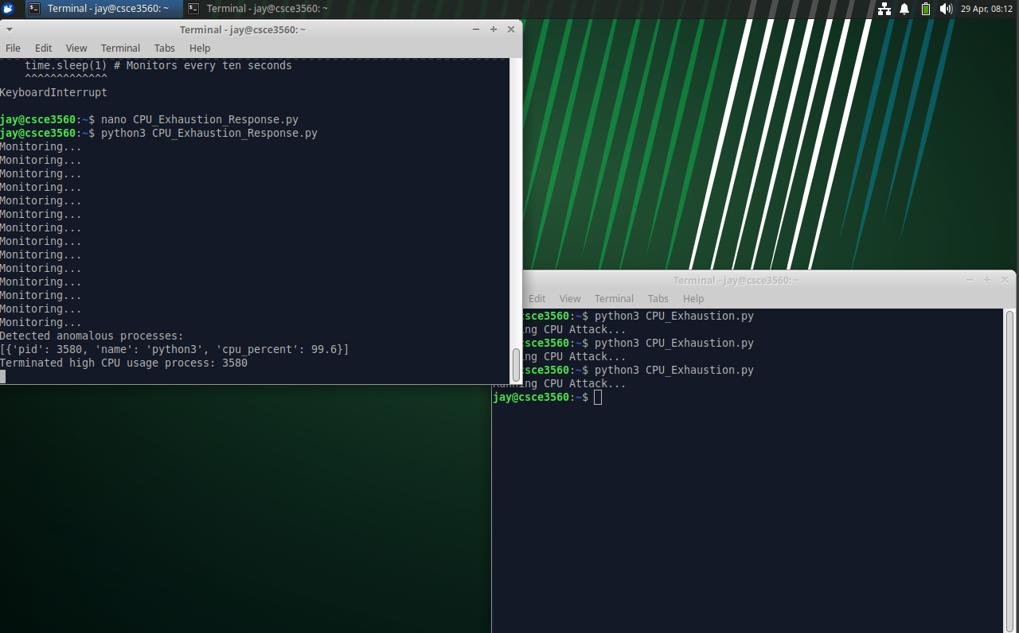
Figure 26: Results of Experiment 3 Part 2
(Took about six and a half minutes to finally mitigate the attack)

While the attack was mitigated, it took far too long. Six and a half minutes is a significant amount of time when considering user patience in cloud environments, along with the expected reliability and availability of cloud services. Thus, increasing monitoring time only serves to harm the client, provider, and especially the system.

Fork bomb
To make sure the fork bomb detection and mitigation systems were effective I conducted experiments within the Docker container environment. My main goal was to measure the speed at which detection was done and also to make sure the mitigation strategy was executed correctly.

Environment Setup:
The experiments were done on a Docker container built by using a Dockerfile running on ubuntu. The container environment used python3.10 psutil, sqlite3 and some standard Linux commands such as psmisc to ensure I can call killall KILL within the container. The detection parameters were set to their default values: PROCESS_THRESHOLD = 800, TIME_WINDOW = 2 seconds, and RATE_THRESHOLD = 25 processes per second.

Procedure: The Docker container was started using docker run. As per the Dockerfile's CMD instruction, this simultaneously launched the monitoring.py, detector.py, and fork_bomb.sh scripts.
Observations: We monitored the standard output of the container.

Observations.
When running all commands at once you do not see the detector or the monitoring outputs due to the fork bomb calling so fast however you can ensure these are running correctly and putting output by removing the fork_bomb.sh within the Dockerfile to see these outputs.

The detector.py script logged an alert message. This is usually triggered by the rate threshold first, followed by the absolute threshold if the limits were not set in place. The detection typically occurred within 2-4 seconds after the bomb started executing.

The killall command terminated the rapidly spawning processes along with the monitoring and detection scripts themselves since they are being run under the same user

This resulted in the system detecting the fork bomb attack and mitigating it by killing all processes which include the container itself. Log entries in monitoring.db confirmed the exponential rise in process count, and the mitigation_log table recorded the timestamp and action of the mitigation event.
Figure 27: Script flow diagram
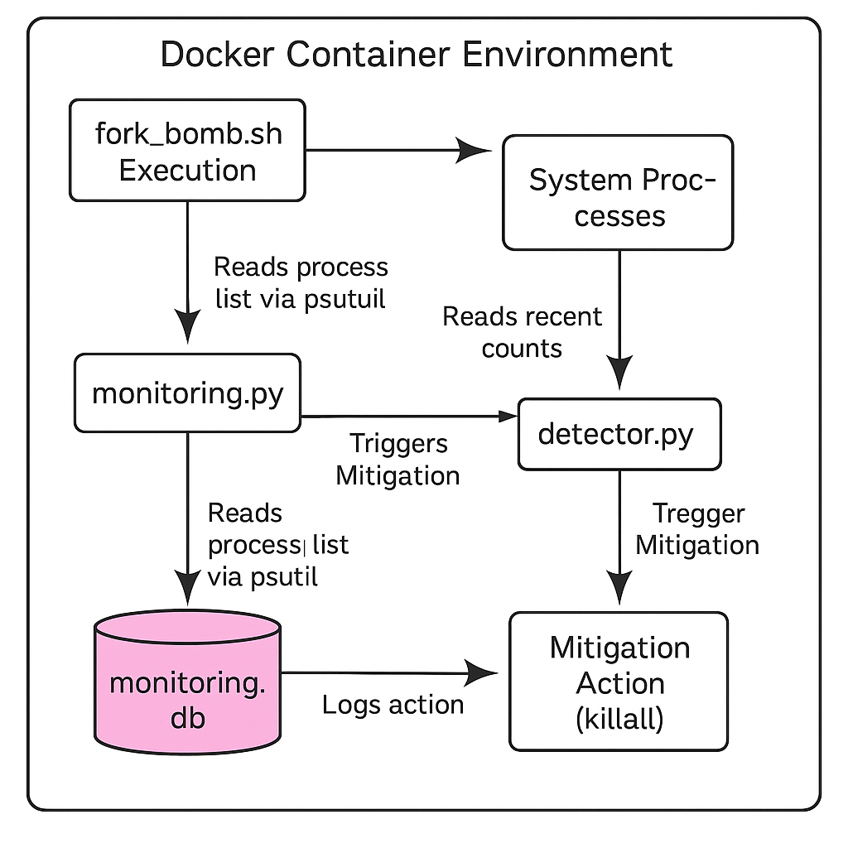

Overall Assessment
The experiments demonstrated that the implemented monitoring, detection (using both absolute and rate-based thresholds), and mitigation strategy is capable of quickly identifying and neutralizing a classic fork bomb attack within the constrained container environment. The detection latency was low, and the mitigation was decisive.

DISCUSSION

SYN Flood
Based on my results from the experiment section, my SYN Flood and mitigation scripts do work. They were effective in attacking and identifying and then responding to a simulated SYN Flood in the virtual environment. However, there were several important operations and challenges that I saw during testing which highlight areas that need future improvement.

One of the harder things about creating these scripts was the challenge of threshold calibration. As seen in the experiments section, configurations that have a lower threshold can trigger a false positive result while overly permissive settings allow the SYN Flood to continue for longer than intended. This shows a common issue in security systems, the tradeoff between sensitivity and accuracy. While the threshold values that I used in testing work in a static environment where I can control everything, in a dynamic environment with fluctuating traffic loads, it might be harder. There will need to be more adaptive mechanisms in place so that the thresholds can adjust to historical traffic patterns or change based on the time of day. In addition to that, in a static environment there isn’t a lot of network activity going on, especially since I used the host - only adapter setting when running these scripts. In a real test with active network use, I don't think that my script would be nearly as effective.

Another challenge that I realized is that there are resource constraints and performance issues in a real world environment. While testing, the CPU and memory usage were within acceptable limits, even while being put under a pretty intense attack. However, the fact that I coded the scripts in Python might prove to be an issue in a real world environment. Python is pretty good when it comes to rapid deployment and readability, but it could have performance limitations in a more advanced or real world environment. In scenarios where there is a large-scale deployment or a more sophisticated attack, my current implementation would most likely need some improvements.

There is also an issue with the heart of my mitigation strategy. The way my script works is that it blocks IP addresses once the threshold values have been hit. While this is an effective strategy in a single source attacker scenario, it would probably be less useful in a Distributed Denial of Service attack (DDoS). In DDoS attacks, the malicious traffic comes from multiple different sources and not just one and they are often also spotted. If I were to increase the agresion of my mitigation script, it might inadvertently affect legitimate traffic in cases where users share an IP, examples being NAT or proxy services. If I were to continue refining my script I would need to add a more nuanced mitigation technique with things like connection rate limiting
per session or integrating it with upstream network defenses.

Deep packet inspection is also something that is missing from my mitigation script. The original plan was to implement this, but during testing none of the SYN attacks were getting blocked, so the idea was scrapped. Now the script mostly focuses on connection patterns like the half open connections and the connection rates. While this is a pretty good method in simpler environments, in a more complex environment it wouldn’t be enough to decide whether a connection is an attack or legitimate traffic since it doesn’t account for more complex attack vectors. Without deep packet inspection, the system's ability to detect stealthier or more blended attacks is severely limited to the point of it actually being a handicap. If I were to incorporate more packet level analysis tools like scapy or a more specialized IDS system, then it could help the detection capabilities of the script. The only downside to this is the resource usage would get higher since more processes are running.

When it comes to the logging mechanism and database management, there isn't really an issue currently with that. It works as intended and is labeled and organized in a user-friendly way. In the future though it might pose an issue. With more and more attack attempts, more firewall rules will start to pile up which could impact the systems performance. If I were to continue working on the script, I would add a cleanup method to the logging and firewall systems. Things like temporary IP bans instead of indefinite ones, clearing out the database after a set amount of time and downloading the logs and then clearing them would all help with maintaining long term efficacy and efficiency.

Looking more towards the future implementation of the mitigation script, there is potential to add a machine learning (ML) element to it. Currently, there is a rule based detection system since it is more simple to implement and also more reliable. If I were to implement a ML algorithm into the script, it would look at the logged connection data over an extended period of time and from that data determine if there is more to a connection than just the static data. I would need to use a lot of data to train the algorithm, so the implementation would have to wait a while while the logging system gets data to feed it. From there, the algorithm can learn what is legitimate traffic and what might be cause for concern. This would introduce more complexity and computation overhead though which would not be ideal since the mitigation script isn’t supposed to use too many resources.

Overall, the mitigation and attack scripts act as they are supposed to, the only caveat being that they are being tested in a controlled environment and don’t have dynamic data analysis. There are of course improvements that can be made, but adding these could compromise the original intention behind creating the scripts. The goal was to make a lightweight mitigation system, and that was completed.

Slowloris
Whenever I first started working on my code I was having a little bit of issues with getting everything to connect together but then I got that to work. I was also having an issue because initially I didn't have a container that was running my mitigate and detect file but then I got that to work. Then I was having an issue with the database but then I used sqlite inside the detect and mitigate and it will output it straight into a DB file, I used a function and called it DatabaseLogger to log all the Ips.

The biggest issue I was having is the manual unblocking on my Ip. So what I did is that I implemented an unblock expired ips, which waits and then if the IP is not actively being blocked by the mitigation then the ip will get unblocked. If its unblocked it doesn't mean that it can't be blocked again. The mitigate code will still be able to mitigate it.

This is not an issue I had but some other thoughts I had was that I could add a couple moe features later on in the code. This project works how it's supposed to by having a slowloris attack and defend, but later on I am able to improve solutions to detect SYN-flood like behavior even if payload is not visible and I would be able to detect more than just a slowloris attack. Later on I would be able to also add a real time dashboard, which would be easy because i have a lot of the needed material, this can show Ips that are blocked actively and it can also show the detection process live with updates. My team and I would also be able to combine out processes all together and run a big detection/mitigation code that would work for all of our attacks. I could also add logging with severity, this would work because it would sort the IPs by how severe the attack was (for ex: many sockets from on IP= higher risk =more severe.

CPU exhaustion
A former issue I had was the cluttered output of my script. In previous versions of my script, it would try to terminate the same process multiple times, despite failing before, along with detecting previous processes as anomalous. These problems would clog up the output and make it hard to follow what my script was outputting. This was a simple fix, though, as I simply needed to check if processes were alive in my data and create a new set to track failed terminations. Checking if processes were still alive was a great way to get rid of previously terminated processes, that way a “failed to terminate” message does not redundantly output to the terminal. When anomalies are put to termination, it is confirmed that if the termination fails, it will not be tried again since it will be added to “failed_terminations”.

A prominent issue I have had is the accidental closing of the terminal. I still haven't found the main culprit behind this, but I suspect a certain process is being terminated that should not be terminated. Perhaps a parent process, in which the child will have to forcibly close itself.

In the “detected anomaly” outputs, you can clearly see the CPU usage percentage. Sometimes, these values are almost negligible, so for IsolationForest to label them as anomalies calls into question my whole detection system. It may be the fact that they are so abnormally low, yet still alive, that it causes IsolationForest to deem them as anomalies, since they technically are. Still, it can not be risked for these processes with negligible CPU usage to be flagged as anomalies. They will be marked for termination, which may lead to unwanted processes being killed, resulting in even more unwanted consequences. This likely connects back to my previous issue mentioned, about accidental closing of the terminal.

All in all, the script can detect malicious processes, but it can also fall victim to false positives. These false positives can result in unwanted processes being wrongfully terminated, calling for more effective filtering of processes or anomaly prediction.

Fork Bomb
The experiment results showed that the system I created for detecting and mitigating fork bomb attacks within a container showed that it is effective at mitigating them. By combining a continuous process count monitoring method by using psutil logging this data to SQLite and a dual controlled detection method allowed for a quick identification of fork bombs and the ability to act upon them quickly.
However there are some key takeaways to this:

1. killall -KILL -u {username} is a very powerful call. It terminates all processes by the user logging them out or in my case killing the container. This guarantees stopping the fork bomb but also kills the monitoring and detection scripts as well as killing other legitimate scripts at the same time. This lead to a complete reset of the container when trying to use it again.

2. Threshold sensitivity is a hard one to do since process counts vary all the time. The threshold I put in place worked very well for me however for another user that might be too low and would need to be increased to ensure no false positives occur.
3. It's crucial to recognize that this runtime detection system acts as a secondary defense layer within the container. The primary and most robust defense against fork bombs remains the proper configuration of resource limits at the host level.

CONCLUSION

This project as a whole focused mainly on the topic of Denial of Service Attacks (DOS) within a simulated cloud environment. We designed and implemented mitigation strategies for four of the more common DOS/DDOS attacks which are: SYN Flood, CPU Exhaustion, Slowloris, and Fork Bomb attacks.

Our approach used custom built python codes and using libraries such as psutil scikit-learn and sqlite3 as well as standard linux commands. For each attack we used a specialized monitoring detection and mitigation mechanism. The SYN Flood mitigation effectively identified attack patterns based on half-open connections and connection rates, responding with dynamic iptables rules. The Slowloris defense combined connection counting (netstat) and payload analysis (tcpdump) to detect any incomplete HTTP requests. The CPU Exhaustion mitigation used psutil for monitoring and scikit-learn's IsolationForest for detecting anomalies, making sure to terminate suspect processes by PID. Finally, the Fork Bomb defense monitored rapid process proliferation using psutil and applied a decisive killall command upon detection via threshold and rate analysis.

All experiments were conducted within a controlled VM and container environments. All of our systems were able to detect the targeted attack and effectively mitigate them. The results highlight the effects of implementing lightweight security measures tailored to the specific threats.

Overall this work provided a good demonstration of simulating, detecting and mitigating some common DoS attacks in a cloud environment. It gave us some valuable insight into the strengths and weakness of certain host based defenses and gave us a strong foundation for later in life if we need to develop more sophisticated codes

REFERENCES
[1] J. Mirkovic and P. Reiher, "A taxonomy of DDoS attack and DDoS defense mechanisms," Computer Networks, vol. 43, no. 5, pp. 617-634, 2003. [Online]. Available: https://www.sciencedirect.com/science/article/abs/pii/S108480450700077X
[2] D. Dimitriadis and C. Polychronopoulos, "Detection Methods Against SYN Flooding Attacks," Computing Online, vol. 19, no. 2, pp. 185-193, 2018. [Online]. Available: https://computingonline.net/computing/article/view/1889
[3] J. Zhang, L. Wang, and Y. Liu, "Real-Time Detection of SYN Flooding Attacks Based on Dynamic Thresholds," in Proceedings of the IEEE International Conference on Communications (ICC), 2020. [Online]. Available: https://ieeexplore.ieee.org/abstract/document/9253566
[4] RSnake, "Slowloris HTTP DoS," Ha.ckers.org, 2009. [Online]. Available: https://ha.ckers.org/slowloris/
[5] C. Kreibich, N. Weaver, B. Nechaev, and V. Paxson, "Netalyzr: Illuminating the Edge Network," ACM SIGCOMM Conference, 2010.
[6] Suricata IDS Documentation, "HTTP DoS Detection Modules," Open Information Security Foundation, 2023. [Online]. Available: https://suricata.readthedocs.io/
[7] Apache HTTP Server Project, "Timeout Directives," Apache Documentation, 2023. [Online]. Available: https://httpd.apache.org/docs/current/mod/core.html#timeout
[8] D. Merkel, "Docker: Lightweight Linux Containers for Consistent Development and Deployment," Linux Journal, 2014.
[9] W. Meng, B. Lee, D. Shands, and L. Wang, "Rampart: Protecting Web Applications from CPU-Exhaustion Denial-of-Service Attacks," in Proceedings of the 27th USENIX Security Symposium, Baltimore, MD, USA, 2018. [Online]. Available: https://www.usenix.org/conference/usenixsecurity18/presentation/meng
[10] R. Zhang and K. Chen, "Improvements on the WTLS protocol to avoid denial of service attacks," Computers & Security, vol. 24, no. 1, pp. 76–82, Feb. 2005. [Online]. Available: https://doi.org/10.1016/j.cose.2004.10.002
[11] M. Zhan, Y. Li, H. Yang, G. Yu, B. Li, and W. Wang, "Coda: Runtime Detection of Application-Layer CPU-Exhaustion DoS Attacks in Containers," IEEE Transactions on Services Computing, vol. 16, no. 3, pp. 1686–1697, May–Jun. 2023. [Online]. Available: https://www.computer.org/csdl/journal/sc/2023/03/09842371/1FlLYNeUxRC
[12] Scikit-learn developers, “sklearn.ensemble.IsolationForest,” Scikit-learn Documentation, [Online]. Available: https://scikit-learn.org/stable/modules/generated/sklearn.ensemble.IsolationForest.html
[13] Wikipedia contributors. (n.d.). Fork bomb. Wikipedia. https://en.wikipedia.org/wiki/Fork_bomb
[14] Utale, I. (2021, July 12). What is a Docker fork bomb? Medium. https://ion-utale.medium.com/what-is-a-docker-fork-bomb-ef081b829118
[15] GeeksforGeeks. (2023, May 25). Python SQLite tutorial. https://www.geeksforgeeks.org/python-sqlite/
[16] Harichselvam, C. (2020, May 18). SQLite3 in Python for database management: An introduction. Medium. https://medium.com/@harichselvamc/sqlite3-in-python-for-database-management-an-introduction-9da6009b2110
[17 ]Rodola, G. (n.d.). psutil documentation. https://psutil.readthedocs.io/en/stable/
[18] N. Khandelwal, S. Lal, and A. Jindal, "Detection of slow HTTP DDoS attacks using traffic profiling," 2016 Symposium on Colossal Data Analysis and Networking (CDAN), Indore, India, 2016, pp. 1–5, doi: 10.1109/CDAN.2016.7570904
[19] A. Shekyan and A. Dovgopoly, “Detecting Slow HTTP Attacks Based on Traffic Behavior and Header Analysis,” presented at Black Hat Europe, Amsterdam, Netherlands, Mar. 2012. [Online]. Available: https://media.blackhat.com/bh-eu-12/Dovgopoly/bh-eu-12-Dovgopoly-Slow_HTTP_Attacks-Slides.pdf

